Nam June PAIK (1932-2006)
Nam June Paik was a Korean-born American artist who achieved international notoriety for his destructive Neo-Dada activities and visionary aesthetic experiments with electronic media. Born to a wealthy family in Seoul during Japanese colonial rule, Paik took private music lessons throughout his adolescence. After moving to Japan in 1951, he enrolled in the University of Tokyo, where he studied music, aesthetics, and art history and graduated with a thesis on the composer Arnold Schoenberg in 1956. In the late 1950s and early 1960s, however, he turned away from the university setting to associate himself with a network of progressive artists such as John Cage and the Fluxus group. While studying in Germany in the late 1950s, Paik began exploring electronic media as an art form. Yet, far from being negative or polemical, Paik’s attitude toward the televisual environment was marked by a radical openness. He explored the aesthetic potential of television and video in an all-encompassing way. Paik’s exploration encompassed manipulation of television signals or scan lines, videotape production and television transmission, live satellite telecast and video sculpture and environment. Yet Paik was by no means naïve or conformist in his approach, instead he hijacked broadcast signals, redressing one-way communication and rechanneling energy into an alternative mode of communication.
Sharing cross-disciplinary impulses and defiant gestures, Paik’s experiments with musical composition and performance art took the form of iconoclasm. Etude for Piano Forte (1960), for example, featured Paik playing a piece by Chopin and cutting off audience member John Cage’s necktie, and in One for Violin Solo (1962) he destroyed the instrument. His notoriety continued after moving to New York in 1964, reaching its peak in his Opera Sextronique (1967), during which his performance collaborator Charlotte Moorman was arrested for playing the cello topless. Paik’s first solo show ‘Exposition of Music—Electronic Television’ in 1963 displayed thirteen altered television sets, along with pianos which were later destroyed by Joseph Beuys, signalling the beginning of his lifelong project exploring the aesthetic potential of television and video.
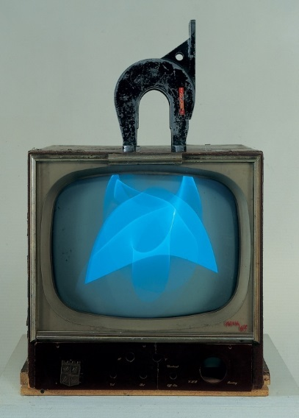
Nam June Paik, Magnet TV, 1965 http://whitney.org/Collection/NamJunePaik/8660aB
As a world renowned artist born in Korea, Paik became known to South Korean artists and intellectuals as famous but suspiciously scandalous, stimulating a desire towards international contemporaneity in some Korean ‘Happeners’ in the late 1960s. His fame spread nationwide in the 1980s when he took part in two national events, the 1986 Asian Games and the 1988 Seoul Olympic Games, with his two satellite installations, Bye-Bye Kipling (1986) and Wrap Around the World (1988).

Although living a transnational life until his death in 2006 in Miami, Paik is regarded as the most representative artist in Korea, which is corroborated by the fact that the National Museum of Modern and Contemporary Art has offered its central rotunda for Paik’s video installation The More The Better (1988) composed of 1003 TV monitors since its installation in 1988.
References and further reading
Hanhardt, John G., Ken Hakuta, and Nam June Paik. (2012) Nam June Paik: Global Visionary. Washington, DC: Smithsonian American Art Museum.

Joselit, David. (2007) Feedback: Television Against Democracy. Cambridge, Mass.: MIT Press.

Paik, Nam June, and Judson Rosebush. (1974) Nam June Paik: videa ‘n’ videology, 1959-1973. Syracuse, N.Y.: Everson Museum of Art.

